Remembering Marie Hart
See below some of our members’ memories of our founding member, Marie Hart,
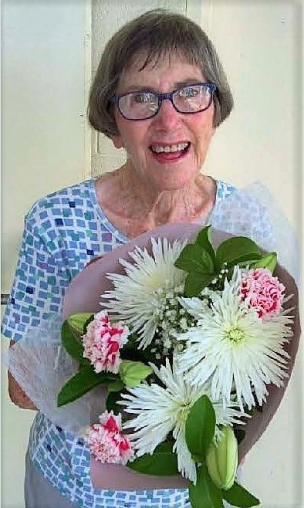
who passed away in March 2023.
Memories of Marie - By Jackie Chalmers
I don’t think she was even 5 foot tall! But every inch packed a punch of enthusiasm and energy – a human dynamo – generating that energy to all she met.

Marie was the supreme gatherer of facts: She followed our lives, every individual encounter she ‘gleaned’ what was going on in our lives, and she recorded it in her notebook. Marie kept and added to these individual notes of our lives everywhere she went. Consequently, we all looked forward to reading her regular column ‘All in the Family’ in the Society’s quarterly Journal, The Cedar Log. This was one of the many ways Marie kept us all together as family – her family of Family Historians!

To me personally, Marie was my Mentor – setting my direction and commitment over 10 years ago when she nominated me to the Committee; giving me encouragement to complete my Certification with the Society of Australian Genealogists; giving me reasons to stick at it, to hang in and keep going!

Marie never spelt it out to me as to what to do, which way to go, what was important, should I continue – she didn’t have to – the way Marie lived, worked, contributed, supported, encouraged, followed through – she was a living example and it was that example that led us.
Marie Hart when the RTFH Society presented her flowers for her 90th birthday in 2020

More Memories:
- Her initial struggle with technology – Bearing in mind that the first Newsletter or Journal, of 6 pages A4, Marie typed in September 1984 – she persevered and was soon emailing congratulations to the editorial team in 2015 the day after the March edition hit the streets!
- Marie recycled all her window envelopes – after reading all the overseas and local journals, she would record references to subjects she knew you were interested, in on a small square of paper, insert it into one of these envelopes, with directions to where you could locate this journal in the Marie Hart Library, write your name on the front of the envelope and leave it in the Library mail box. One of these in my possession reads:
12-12-16
Jackie
Using Maps … pp. 238-240 ‘Origins’ (Bucks) … J17896
- Her joy and pride when the 2017 December edition of The Cedar Log was awarded the Nick Vine Hall Award - the plaque that now hangs in the library named after her.
- A picture of Marie - think it was a 90th Birthday – the Players Theatre was in renovation and our meeting was held with black drapes all around us – very sombre setting – Marie was presented with a floral bouquet – her facial expressions of delight lit up the room as we took her photograph!

- Marie couldn’t handle the modern whizz-bang software such as Evernote and Google Earth – but she took an interest in them because you did – I received another one of Marie’s Envelopes with a reference to Evernote in it!
----------------------------------------------

Tribute to Marie – Ann Emery
Marie Hart made a significant contribution to my ongoing family history research. At a time when I was busy with full-time work and raising a family, Marie would feed me articles about Trinidad and Barbados that she found in journals, bringing them to church on Sundays to give them to me. This continued for many years and was amazingly helpful in reigniting my interest in researching my father’s side of the family. She never lost interest in listening to the little gems I discovered and was able to direct my research in ways I would not have otherwise thought. Her bright personality and her dedication to the Family History Society were remarkable and there are many who benefitted from her knowledge and caring nature. Marie was always looking for ways to help others. She was such a blessing in my life.
--------------------------------------------
Other memories
Marie assisted me so much with her little notes on my family that she came across in her research or reading. It was so helpful and appreciated. – Joy Morhouse
Marie was a truly lovely lady with the sweetest smile which never left her face. She always had time to talk to me and give me advice when needed. My best wishes to her family. – Jean Ison
After my short talk at one of our Saturday meetings, Marie came up to me and said something about it being complicated research. I exclaimed ‘Oh! was it not understandable?’ and she said ‘No! I just wish I knew how to do all that.’ I don’t think Marie was capable of criticism…she was always so positive! – Carmel Crosby
----------------------------------------------

